 Shri Ramdeobaba College of Engineering & Management, Nagpur 13

Department of Electronics Engineering

Instrumentation and control lab (ENP354)

Semester: V Session: 2023-24 Section: A Batch: A2

******************************************************************************************

Name of Student: Harsh Devendra Mishra Roll Number: A-22

Date of performance of Experiment: 06/12 /2023 Date of Submission of Experiment file: 07/12/2023

******************************************************************************************

# EXPERIMENT NO. 8

Aim of Experiment: - Real world applications: Design of dashboard of Smoke Detector circuit

********************************************************************************************************

Component Required -

1. Smoke Sensor (MQ2/MQ6)
2. Arduino
3. Buzzer
4. LED
5. Power Supply
6. Wire
7. 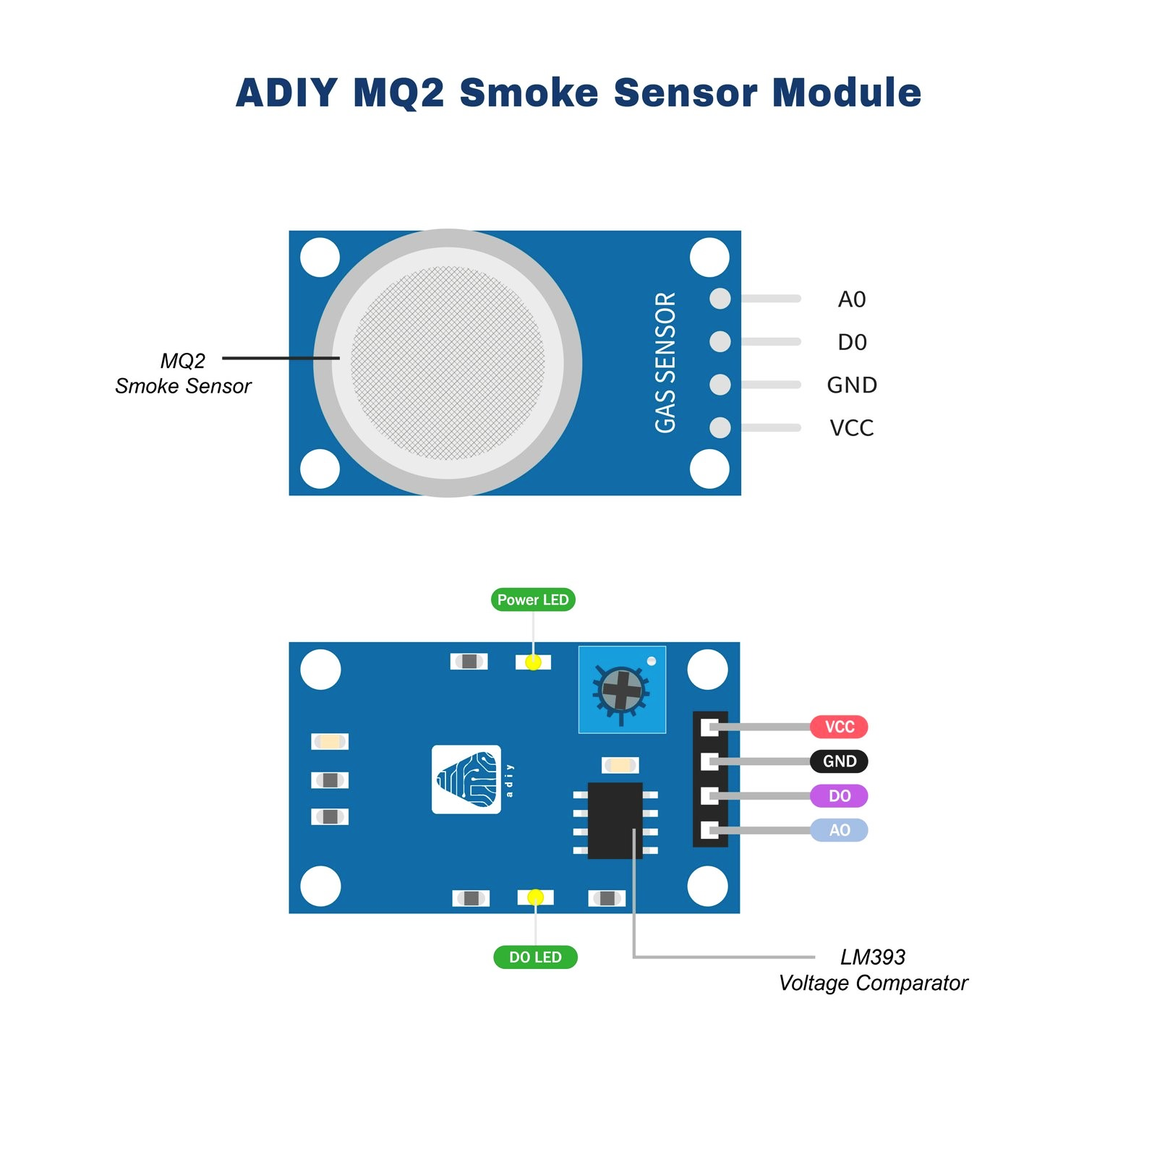Breadboard

Specification of Smoke Sensor -

Smoke sensor is an electronic sensor used for sensing the concentration of gases in the air such as LPG, propane, methane, hydrogen, alcohol, smoke and carbon monoxide.MQ2 gas sensor is also known as chemoreceptor. It contains a sensing material whose resistance changes when it comes in contact with the gas. This change in the value of resistance is used for the detection of gas.

Arduino Board -



Arduino is a single-board Micro-controller meant to make the application more accessible which are interactive objects and its surroundings. The hardware features with an open-source hardware board designed around an 8-bit Atmel AVR micro-controller or a 32-bit Atmel ARM. Current models consists a USB interface, 6 analog input pins and 14 digital I/O pins that allows the user to attach various extension boards. The Arduino Uno board is a microcontroller based on the ATmega328. It has 14 digital input/output pins in which 6 can be used as PWM outputs, a 16 MHz ceramic resonator, an ICSP header, a USB connection, 6 6 analog inputs, a power jack and a reset button. This contains all the required support needed for micro-controller. In order to get started, they are simply connected to a computer with a USB cable or with a AC-to-DC adapter or battery. Arduino Uno Board varies from all other boards and they will not use the FTDI USB-to-serial driver chip in them. It is featured by the Atmega16U2 (Atmega8U2 up to version R2) programmed as a USB-to serial converter.

Block Diagram -

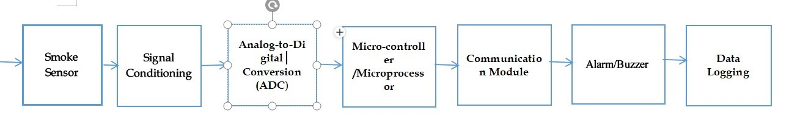

Circuit Diagram -

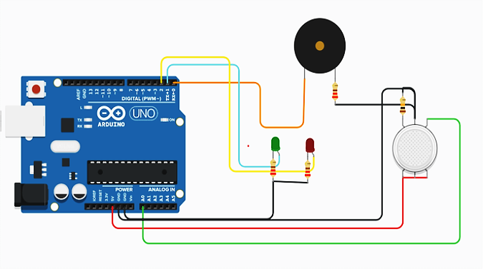

Working -

● Working of this Smoke Detector Alarm Circuit is easy. In this project, we implemented a simple Smoke Detector

Circuit with adjustable sensitivity.

● We used a Smoke Sensor MQ-2 as the main sensory device.

● Initially, when the air is clean, the conductivity between the electrodes is less, as the resistance is in the order of 50KΩ. The inverting terminal input of comparator is higher than the non-inverting terminal input. The indicator LED is OFF.

● In the event of fire, when the sensor is filled with smoke, the resistance of the sensor falls to 5KΩ and the conductivity between the electrodes increases.

● This provides a higher input at the non-inverting terminal of comparator than the inverting terminal and the output of comparator is high. The alarming LED is turned ON as an indication of presence of smoke.

● Whenever smoke sensor senses smoke, it reduces its resistance and due to this decrease in resistance, voltage across the base of the transistor increases.

● Now when the voltage at the base terminal of transistor become more than or equal to 0.70v then transistor turns on and LED lights up and buzzer also starts beeping.

● And when there is no Smoke, both the indication components turn off as the voltage across base terminal of transistor goes below the 0.70v.

Advantages -

1. Detects products of combustion.
2. Detects fire.
3. Low cost.
4. High portability
5. Low power consumption
6. Easy to understand
7. Easy to install

Application -

1. Commercial buildings
2. Trains
3. Bedrooms
4. Hospitals

# Conclusion -

● Smoke detector is one of the easier and low cost.

● Most of the industries use it, because it works fast and most effective.

● In future the use of smoke detection will increases.